1. Code: **stress.csv**

Output:

Subject Group PSSbefore PSSafter

1 A1 Sport 25 13

2 A3 Sport 17 15

3 A4 Sport 12 13

4 A5 Sport 21 22

5 A6 Sport 29 25

6 A7 Sport 28 24

7 A8 Sport 21 19

8 B1 Sport 18 19

9 B2 Sport 20 24

10 B3 Sport 29 21

11 B4 Sport 27 22

12 B5 Sport 44 33

13 B6 Sport 23 8

14 B7 Sport 18 12

15 B8 Sport 27 30

16 A2 Control 0 16

17 C1 Control 30 27

18 C2 Control 12 31

19 C3 Control 29 21

20 C4 Control 25 33

21 C6 Control 2 9

22 C7 Control 6 26

23 C8 Control 20 20

24 C9 Control 27 28

25 C10 Control 14 21

26 C11 Control 15 29

b) Code: **head(stress.csv)**

Output:

Subject Group PSSbefore PSSafter

1 A1 Sport 25 13

2 A3 Sport 17 15

3 A4 Sport 12 13

4 A5 Sport 21 22

5 A6 Sport 29 25

6 A7 Sport 28 24

c) Code: **tail(stress.csv)**

Output:

Subject Group PSSbefore PSSafter

21 C6 Control 2 9

22 C7 Control 6 26

23 C8 Control 20 20

24 C9 Control 27 28

25 C10 Control 14 21

26 C11 Control 15 29

d) Code: **stress.csv$Differences<-stress.csv$PSSafter-stress.csv$PSSbefore**

Output:

Subject Group PSSbefore PSSafter Differences

1 A1 Sport 25 13 -12

2 A3 Sport 17 15 -2

3 A4 Sport 12 13 1

4 A5 Sport 21 22 1

5 A6 Sport 29 25 -4

6 A7 Sport 28 24 -4

7 A8 Sport 21 19 -2

8 B1 Sport 18 19 1

9 B2 Sport 20 24 4

10 B3 Sport 29 21 -8

11 B4 Sport 27 22 -5

12 B5 Sport 44 33 -11

13 B6 Sport 23 8 -15

14 B7 Sport 18 12 -6

15 B8 Sport 27 30 3

16 A2 Control 0 16 16

17 C1 Control 30 27 -3

18 C2 Control 12 31 19

19 C3 Control 29 21 -8

20 C4 Control 25 33 8

21 C6 Control 2 9 7

22 C7 Control 6 26 20

23 C8 Control 20 20 0

24 C9 Control 27 28 1

25 C10 Control 14 21 7

26 C11 Control 15 29 14

e)

i. Code: **stress.csv$Differences**

Output: [1] -12 -2 1 1 -4 -4 -2 1 4 -8 -5 -11 -15 -6 3 16 -3

[18] 19 -8 8 7 20 0 1 7 14

ii. Code: **mean(stress.csv$Differences)**

Output: [1] 0.8461538

Code: **sd(stress.csv$Differences)**

Output: [1] 9.194313

iii. Code: **summary(stress.csv)**

Output:

Subject Group PSSbefore PSSafter

A1 : 1 Control:11 Min. : 0.00 Min. : 8.00

A2 : 1 Sport :15 1st Qu.:15.50 1st Qu.:16.75

A3 : 1 Median :21.00 Median :21.50

A4 : 1 Mean :20.73 Mean :21.58

A5 : 1 3rd Qu.:27.00 3rd Qu.:26.75

A6 : 1 Max. :44.00 Max. :33.00

(Other):20

Differences

Min. :-15.0000

1st Qu.: -4.7500

Median : 0.5000

Mean : 0.8462

3rd Qu.: 6.2500

Max. : 20.0000

iv. Code: **hist(stress.csv$Differences)**

Output: 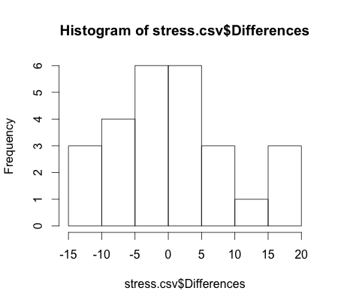

v. Code: **boxplot(stress.csv$Differences)**

Output: 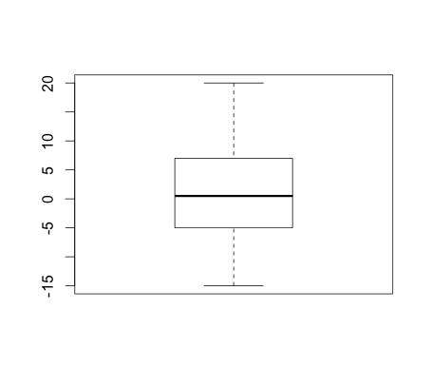

2. When analyzing the data it appears that we have the same frequency of increase and decrease in stress levels. It is unclear in the histogram which inmates were part of the control and sport group. The distribution of the box plot looks fairly even aside from the larger amount of inmates seeing a stress level difference of <0. However, we once again do not know if they are sport or control based on the histogram and box plot. Based off the mean value, 0.846 I would say that stress levels have actually increased. If they had significantly decreased wouldn’t we see a negative number? According to these results the inmates saw a very small change in stress level.